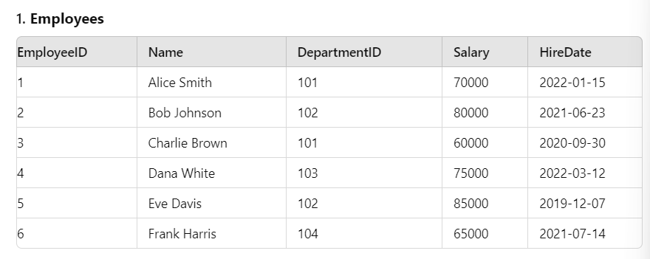

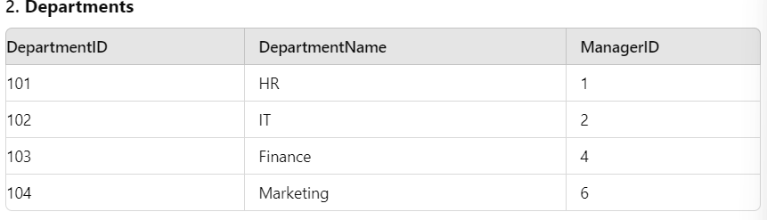

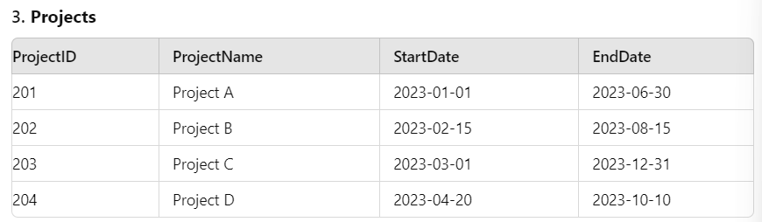

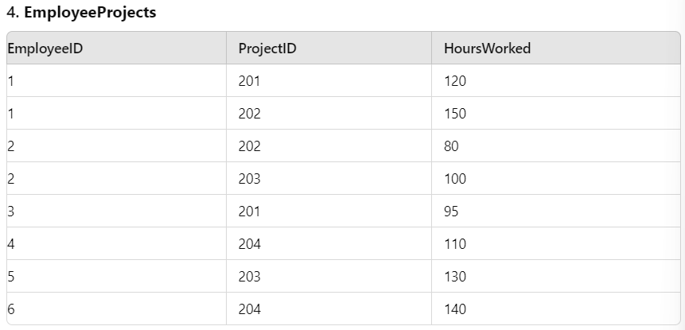

1. Total Salary of All Employees
2. Average Salary per Department
3. Maximum and Minimum Salary in the Company
4. Number of Employees per Department
5. Total Hours Worked per Project
6. Total Salary of Employees in Each Department
7. Average Salary of Employees per Department
8. Maximum Salary in Each Department
9. Minimum Salary in Each Department
10. Total Hours Worked on Each Project
11. Average Hours Worked per Project
12. Employee and Department Details
13. Total Hours Worked by Employees in Each Project
14. Projects and Their Total Hours Worked by Employees
15. Employees Who Worked on Projects in Each Department
16. Departments with Their Managers and Total Employees